# Scene 1 - Intro

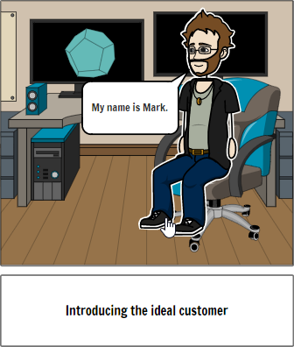

This is Mark. Mark is a recent art grad from Humber, looking to show off his work online and make some cash while doing so. He wants to quit his current job making models or kid’s cartoon and go full time as a 3D game artist in the AAA game industry

# Scene 2 – Problem 1

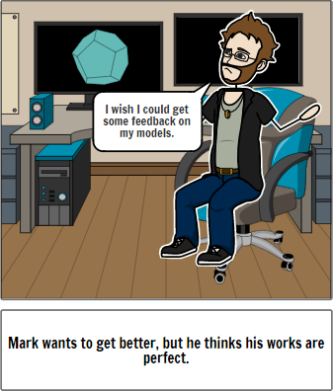

Mark has always been work

# Scene 3 – Problem 2

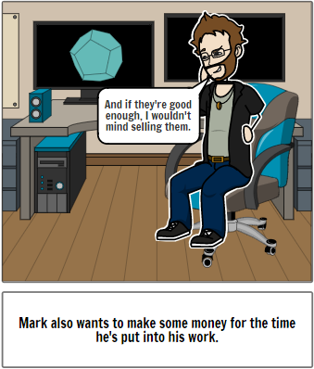

But Mark needs more money. Ever since the lockdown, freelance jobs have been harder to come by, and his supplementary income is coming to a stop.

# Scene 4 – Problem 3

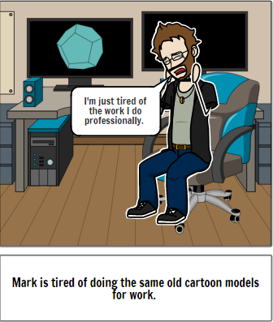

Mark is tired of doing the same old cartoon models for work. What Mark really enjoys is modeling weapons and armor for medieval fantasy settings.

# Scene 5 – Self Introduction

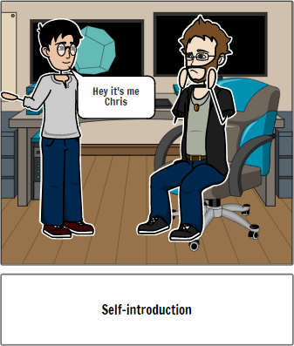

Hey it’s me Chris, have you heard of 3D Gallery?

# Scene 6 – Solution 1

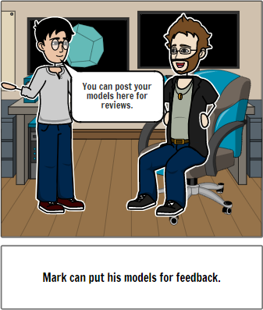

If you are ever feeling like you need some feedback, feel free to post your model up! Other users can comment on your work and let you know what they think.

# Scene 7 – Solution 2

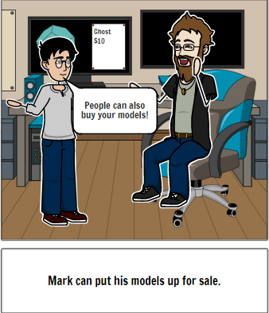

And if someone really, really likes it, and can find a use for it you can put it up for sale! Finally, a way to passively make money for your hard work.

# Scene 8 – Solution 3

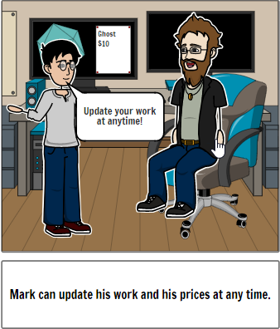

You can also take all the feedback you receive, improve your model, and then re-upload it. Feel free to update the price to reflect the added quality to your model.

# Scene 9 – Describe the Idea

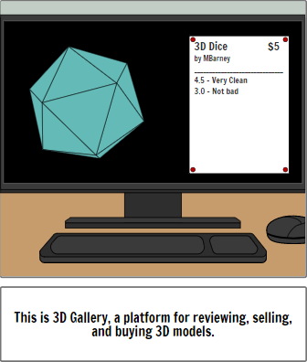

This is 3D Gallery, a platform for artists to display, and sell their models, and for users to review, and buy models that fit their needs.

# Scene 10 – Competitive advantage

# 

With 3D Gallery, you can review the models as if you had the original file!

Pan, zoom, and rotate the camera around the model, viewing it as you like.

Fully rigged character models mean that they can be animated in the browser, letting users look for visual artifacts and be assured of the quality of work.

Also feel free to change model textures in browser, as provided by the artist.

# Scene 11 – Summary/social media

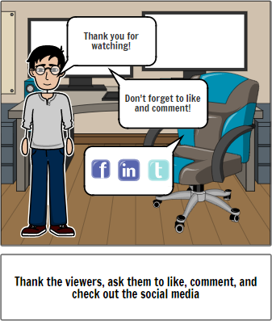

If you would like to see 3D Gallery become reality, click on the Kickstarter link. To keep up to date on our latest news, as well as connect with our community, feel free to follow us on twitter. To know more about our business, please check out our facebook and LinkedIn pages. Thanks for watching!